Participants
•Customer – Noa Akerman
•Designer – Matan Dan On
•Reviewer – Lior Sheiner
EventPro Rentals – Main Use Case
EventPro Rentals rents equipment for private and business events. A customer rents equipment for an event, and the employee enters the customer, event, and rental details into the system. The system checks equipment availability before creating the rental order and also manages deliveries, pickups, and returned equipment.
Customer Requirements
- The system should store customer details and rental order history.
- The system should store equipment information including equipment category, available quantity, rental price, and condition. The company manages equipment according to equipment type and quantity rather than tracking each physical item separately.
- The system should track equipment availability according to rental dates, quantities, and equipment condition.
Equipment may become unavailable because it is already rented for overlapping dates, under maintenance, or damaged.
- The system should create rental orders containing customer information, rental dates, and rented equipment quantities.
- The system should store delivery dates, pickup dates, addresses, and pickup completion status.
Designer Understanding of the Use Case
As the designer, I understand that the main challenges in this system are equipment availability, inventory tracking, and operational management.
I understand that equipment availability depends on rental periods, quantities, and equipment condition rather than a simple static status.
I also understand that the company manages equipment according to equipment type and quantity instead of tracking every physical item separately.
In addition, the system needs to track whether equipment was actually collected after events in order to support daily operations and equipment availability management.
Discussion 1 – Organizing Rental Information
Discussion between Customer and Designer
Customer
We wanted employees to quickly access customer and rental information while creating rental orders.
Designer
I explained that separating customers, rental orders, and equipment into dedicated tables would improve organization and reduce duplicated information.
Discussion between Designer and Reviewer
Designer
I suggested separating the system into dedicated tables for the main business entities.
Reviewer
I explained that storing all information together could create duplicated data and make the system difficult to maintain.
Final Decision
We agreed to separate the system into tables such as Customers, Equipment, Rental_Orders, and Deliveries.
Discussion 2 – Equipment Availability
Discussion between Customer and Designer
Customer
We wanted employees to know whether equipment was available before approving a rental order.
Designer
I explained that equipment availability should be calculated dynamically according to rental dates, rented quantities, and equipment condition.
Discussion between Designer and Reviewer
Designer
I suggested determining availability according to rental periods and quantities.
Reviewer
I explained that the system should also consider overlapping rental periods and damaged or unavailable equipment.
Final Decision
We agreed that equipment availability would depend on rental periods, quantities, and equipment condition rather than a simple available/not available field.
Discussion 3 – Equipment Tracking
Discussion between Customer and Designer
Customer
We wanted employees to easily monitor inventory during busy event periods.
Designer
I explained that managing equipment according to equipment type and quantity would better fit the company’s daily operations.
Discussion between Designer and Reviewer
Designer
I suggested managing equipment according to quantities instead of tracking each physical item separately.
Reviewer
I explained that the company mainly works with equipment quantities rather than individually tracked items.
Final Decision
We agreed that the system would manage equipment according to equipment type and quantity rather than by individually identified physical items. For example, the system tracks quantities of chairs or speakers instead of assigning a separate identifier to each physical item.
Discussion 4 – Delivery and Pickup Tracking
Discussion between Customer and Designer
Customer
We wanted employees to know whether equipment was actually collected after events.
Designer
I explained that storing only pickup dates would not be enough because some pickups may be delayed or forgotten.
Discussion between Designer and Reviewer
Designer
I suggested adding pickup completion tracking to the system.
Reviewer
I explained that storing pickup completion information in addition to pickup dates would improve operational tracking.
Final Decision
We agreed that the system would store delivery dates, pickup dates, addresses, and pickup completion status.
Final Agreed System Design
The final database design includes separate tables for customers, events, equipment, rental orders, order items, deliveries, payments, and return tracking.
The tables are connected using primary keys and foreign keys in order to maintain organized and reliable data.
The design supports:
- Equipment availability checks according to rental periods and quantities
- Delivery and pickup tracking
- Tracking damaged or unavailable equipment
The full database structure is presented in the schema diagram.
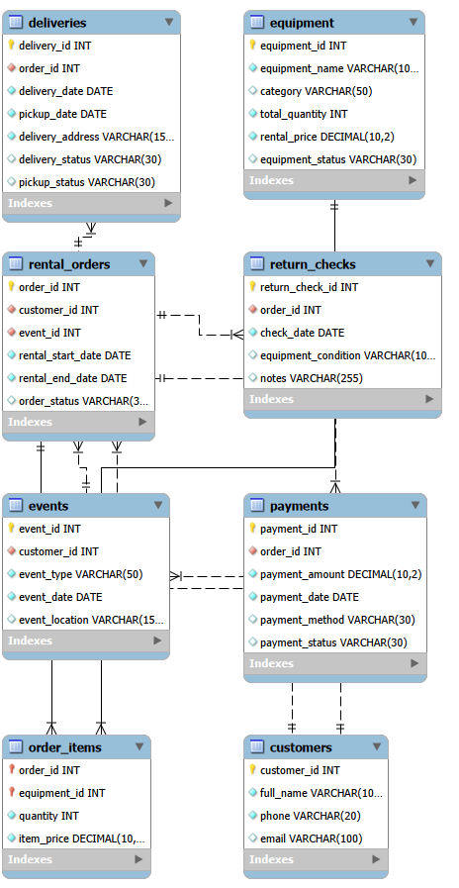

Reviewer Summary
As the reviewer, I verified that the final database design fits the customer requirements and follows normalization principles.
The main improvements included separating large tables, improving availability tracking according to rental periods, adding pickup completion tracking, and reducing duplicated data.
Overall, the final database design provides an organized and reliable solution for managing EventPro Rentals operations.

